DESIGN TYPOLOGIES OF MOSQUES AND MADRASAS BELONGING TO SELJUK AND OTTOMAN CIVILIZATIONS IN KONYA

SERHAT ANIKTAR, SAHIKA OZDEMIR, AHMET KURNAZ

ABSTRACT

Konya, which has been an important city since the prehistoric period, has reached its present identity by overlapping different layers of civilization. Within the context of the architectural traces of these layers of civilization, it is aimed to document how the Seljuk capital city of Konya developed, the present coexistence of the traces of different civilizations, the typological analysis of the architectural identity of the city, from the upper scale to the structure and detail scale. The identity gained by the city in the historical process changes with the ongoing construction works. The problem of protecting the cultural heritage, which reflects our tradition, is faced with the arrangements made depending on today's needs. In order to protect this heritage and to create a guide in the design of new buildings belonging to our civilization, in a whole work, the mosques and madrasahs of the Seljuk and Ottoman civilizations determined in Konya were analyzed together with their current surroundings, documented with photographs, design, building element, construction technique and material typologies were removed, damage conditions were determined and energy models were prepared. In this study, only the analysis of design typologies is included. Typology is not just a classification and statistical process, but a process of analyzing the physical functions and layouts of buildings, reducing them to be included in a typological series and aiming for formal outcome. For this reason, typological analysis studies are important. In this study, the plans and sections of mosques and madrasahs belonging to the Seljuk and Ottoman civilizations determined in Konya were analyzed by processing the existing surrounding tissue. A compilation was made in the light of the information in the literature and specific buildings. It has been argued that the Seljuk and Ottoman buildings, which are located in the outer castle of Konya and known to have an effect on the formation of the city center, will create an awareness in order to protect them into the future with this work.

Key words: Konya Mosques, Konya Madrasas, Seljuk Architecture, Ottoman Architecture, Design Typologies

1. INTRODUCTION

Konya has been one of the most important centers of Turkish-Islamic culture and art in Anatolia as a city that has preserved its importance as the capital of the Anatolian Seljuk State and its position on the caravan roads of the Silk Road in Anatolia [1].
The conquest of Konya by the victory of the Turks in Malazgirt and then becoming the capital is one of the turning points of Turkish history. The city assumed the duty of being the capital city from the foundation of the Anatolian Seljuk State until its disappearance, and as a result, the transportation roads became the intersection point. During this period, especially due to the importance given to trade, important roads were created and many inns and caravanserais were built on these roads [2]. Konya, an important city since the prehistoric period, has reached its current identity with the overlap of different cultural layers.
The monumental buildings built in Konya, especially in the Seljuk and Ottoman periods, are cultural heritage. It is important to make comparative typological analyzes of these buildings which constitute the architectural identity of the city and to document them from the upper scale to the scale of structure and detail. For this purpose, the outer castle, which is not available at the moment, was accepted as the border and Seljuk and Ottoman structures within the center of the city which gained importance in the Seljuk layer were determined. Typological analysis studies were carried out from the upper scale to the detail scale of the identified structures with their immediate surroundings. Comparing these structures with typological analyzes is also important for the protection of cultural heritage.

2. BACKGROUND OF CONTEXTUAL FRAMEWORK

2.1. Seljuk and Ottoman Masjid, Mosque and Madrasah Architecture
Hundreds of monuments such as palaces, mosques, masjids, inns, baths, stenosis healing, madrasah, tombs, dome, fountain, fountain, caravanserai and castle were built in Anatolia during the period of Seljuk period. The rarest examples of Seljuk works are found in Konya, the capital of the period [3].
In the early period of Anatolian Seljuk architecture, it is impossible to speak of a perfect perfection in terms of the dimensions of the buildings, space and facade arrangements. Minarets are in the shape of a tower placed in a corner. In the 13th century, the composition properties of the madrasas, tombs and caravanserais were revealed by proportion [4].
Seljuk architecture has a “inward-oriented” central plan structure depending on the traditional establishment of Asian architecture in terms of space layout. The iwan and the necessary spaces are listed around the inner courtyard [4]. The existence of some features were determined in terms of proportions and in the proportions of the Seljuk constructions.
Anatolian Seljuk architecture; It has unique features in terms of construction types, material, design and decoration. These features; It can be defined as a successful synthesis created in Anatolia as a result of the effects of pre-Islamic Turkish art and Great Seljuk art [4].
In the 12th century, in the north of eastern Anatolia, the Danişments built madrasas with central domes. During the Anatolian Seljuk period, both types of madrasas were used and developed. In fact, there is not much difference between the madrasas with indoor and outdoor courtyards. Since the central space with a closed courtyard is covered with a dome, it has a square or rectangular shape close to a square. The courtyard of the open courtyard type is generally rectangular in length with respect to the entrance axis. It is possible to classify the Seljuk Madrasas under two main headings; madrasas with closed courtyards and madrasas with open courtyards [5].
While Karatay and Thin Minaret Madrasah belong to the madrasas group with closed courtyards, Sircali Madrasa belongs to the madrasas group with open courtyards.
Karpuz, in his book entitled Anatolian Seljuk Architecture, which he wrote in 2001, listed some of the architectural features of the madrasas as follows;
• The plan was established in a central courtyard-iwan layout. Other volumes are located around them.
• The facade with the crown door faces the city area, the main street and has been carefully constructed.
• The crown door usually opens to the entrance iwan opposite the main iwan.
• The courtyard, sometimes with portico, has a flower bed, pool, fountain or well.
• Main iwan is used as classroom or masjid.
• The departments such as student rooms, masjid and winter classrooms are arranged around the courtyard. The toilet is located in a corner of the madrasah or outside [6].
The Anatolian Seljuks opened a new horizon in the field of architecture in 13th century Anatolia with their building types, cut stone monumental architectures and ornaments enriching the space effect. The single-domed masjids built in this period remained among the Seljuk monumental constructions because they were smaller and simpler. However, these constructions have a special importance in order to understand the Seljuk architecture and decoration since it includes an improvement within themselves with different designs [7]. These limited number of constructions also represent a different stage of urban organization. The desire of the great civil servants and the rich to have a magnificent mosque emerges in these masjids. It can be said that a merchant class that strengthened at that time was a building fashion emphasizing the status of society [3]. It is seen that the masjids were built by the rich people of the neighborhood and therefore the same people named the neighborhood where they lived. Therefore, there are examples where the masjid and neighborhood names are the same [1].
Single-domed masjids, built between the neighborhood of small dimensions 4.70 m. to 8.25 m. between the square or square plan, ranging from the dome covered constructions. Ozakin (1998) examined these masjids in three groups according to their plan structures;
• Single room,
• Two spaces (entrance part semi-open masjids, entrance part closed masjids, known as the entrance part of the original form of masjids, entrance section tomb masjids)
• Three-place masjids
Karpuz (2001) examined the masjids in three different groups according to the plan schemes.
• A cubic harim covered with a dome (Konya Sakahane mosque),
• Those with a front space in front of the domed harim (Konya Tas, Sircali, Basarabey masjids). There is a portico or minaret in the front space.
• Those with tomb or lodge rooms in front of or next to the domed harim (Masjids of Konya Tahir and Zuhre, Beyhekim) [8].
Most of the single-place masjids, consisting of a dome-covered cubic harim, were built in the first half of the 13th century, and only two buildings were built in the second half of the 13th century. These are Abdulmumin and Abdulaziz masjids.
In the two-roomed harim and medhal, a second front room was added to the main room. Single-domed structure based on the 13th century; Although it formally forms a whole within itself, it is a limited worship structure since the dimensions of the dome have not yet reached the quality of covering a wide space. For this reason, a second space which is used as an entrance section is added to the front of the domed main space [7]. In the masjids, which have a front space in front of the domed harim, this section can consist of a closed or semi-open space. These spaces, which are designed as closed or semi-open, are the first examples of the last community place. The only example is the Masjid of Cemel Ali Dede. The entrance of the tomb to the west of the harim section is independent of the harim section and is in the north direction.
Those designed as three spaces were examined under three groups. Harim, tomb and medhal consisting of harim, medhal and minarets, the harim, medhal and the second section of the mosque consists of a mosque [8].
The important Seljuk constructions in the outer fortress are Alaeddin Mosque, Iplikci Mosque and Mevlana Tomb. In Alaeddin Mosque, which was built with cut stone, bricks and reused materials, the stonemasonry of the period can be seen in the sentence door on the eastern front and in the inscriptions on the facades.
The classical period of Ottoman architecture is defined by the constructions of Architect Sinan and it is accepted that the period reached the highest level of its formal potential with it. The main feature of Ottoman architectural style is the fact of central universal space. In the architecture of Islamic mosques, there is no tradition other than small masjids that develop in parallel. There is no other style in the late regional styles of Islamic history that goes so far away from the medieval clichés. When the main purpose of the architect was this indivisible central domed space, all the architectural elements were used to reveal the design that would realize this integrity. Architect Sinan's design talent is manifested by a different response to this vision of integrated space in each of his works [3]. Ottoman architecture has a homogeneous character in mosques and other buildings. After the 15th century, stone was mostly used as a single building material. Modest wipings, flat, arched windows on the lower floors, top cover, always dome, crowned garnets with minimal recesses and not more than a few rows, have created a massive, simple architectural style that takes its power from the integrity of the architectural composition. The utility of this utilitarian architecture, which puts the form anxiety when it requires function, consists of simple geometric shapes such as cube, prism, sphere and cylinder. After the 15th century, he abandoned the use of decoration techniques of medieval Turkish architecture such as stone carving, tile mosaic, outside the buildings. Another type of building that is among the Classical Ottoman period buildings in Konya is the tombs. In the Ottomans, tombs are simple structures with square or polygonal planes and domes. Sometimes an entrance ledge or portico is added to the tomb [3].
The classical Ottoman period buildings in the outer fortress are Serafettin Mosque, Selimiye Mosque and the Semahane, Masjid, Dervish cells, Sinan Pasha, Hasan Pasha, Fatma Hatun and Hurrem Pasha tombs of the Mevlana Complex. According to Bas (2006), Serafettin and Selimiye Mosques are the important representatives of the classical Ottoman domed mosques outside of Istanbul. While the central dome was enlarged with a half-dome in the south direction, both of the mosques were carried out in the Serafettin Mosque, unlike the Selimiye Mosque, where the niche of the altar was located [9].
It is known that the plan schemes and settlement characteristics of the Seljuk and Ottoman constructions differ. The analysis of different types is called typological analysis. Among the “type” definitions, class or group with similar characteristics is suitable for use in the field of architecture. Functional structure types such as housing, hospital, bank buildings; Turkish houses, temples belonging to various cultures, Arabic Architecture, French Khan different types of architectural constructions such as different types; types based on the construction system or material, such as steel or wood constructions, high constructions, masonry constructions; or Sinan constructions, the works of Le Courbusier.
Constructions are examined, classified and defined by this approach and their “types are determined. In the light of this definition, the use of the term type in the texts of architectural theorists is limited to certain examples in certain historical periods. Since Vitruvius, however, the concept of typology has been expressed by architectural theorists as the first architectural model idea derived from architecture. Vitruvius worked within the framework of the doctrine of imitation of nature and says that the starting point, main essence, form or model of architecture is presented by nature. Following the publication of Serlio's books in the Renaissance, illustrated architectural studies have expressed the concepts of type and typology in architecture through images rather than words [10].
However, the theoretical perspective of typology of architecture discipline is not a way of generating knowledge based on the evaluation of common characteristics from purely physical, formal classifications, schemas of spatial order, groupings based on an abstract geometric criterion, or concrete realities such as context, use, material and structure. Rather, typology is an understanding of concrete reality through abstract reasoning through experience, and is a subsequent act. The typology here consists of approaches that can be called as a type of upper typology, which allows to evaluate its fictions with artistic interpretation [11].

3. METHODOLOGY

Typology is not only a classification and a statistical process, but also the analysis of the physical functions and patterns of buildings, the reduction of them into a typological series, and a process carried out towards the goal of formal outcome. In this context, the Seljuk and Ottoman mosques and masjids in Konya center, outer fortress were identified and typologically analyzed. While determining the structures, it was paid attention that they caused the formation of important axes in the center and that they were Seljuk masjid constructions which were located in the neighborhoods but not known (Figure 1).
The structures identified are listed below alphabetically:
• Abdulaziz Masjid
• Alaeddin Mosque
• Aziziye Mosque
• Beyhekim Masjid
• Bulgur Tekke Masjid
• Erdemsah Masjid
• Hagia Hasan Masjid
• Hodja Hasan Masjid
• Iplikci Mosque
• Kadi Izzettin Masjid
• Kapu Mosque
• Piri Mehmet Pasha Mosque
• Sahip Ata Mosque
• Selimiye Mosque
• Sircali Madrasah
• Sekerfurus Masjid
• Shams Tabrizi Mosque
• Serafettin Mosque
• Tahir and Zuhre Masjid
• Tercuman Masjid
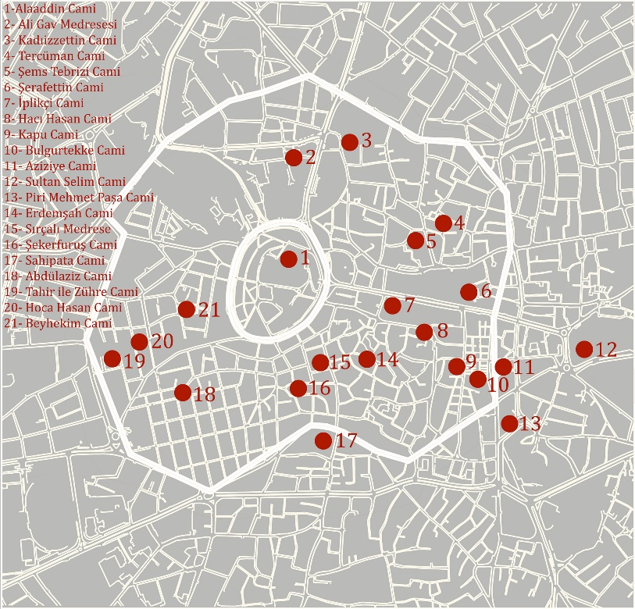

Figure 1. Constructions identified in Konya outer castle
Plans, sections and views of the structures were drawn from the Konya Provincial Directorate of Foundations. In order to analyze the relationship between building-garden, building-street and garden-street, the buildings were viewed from above with drone and their current status was determined. The plans of the constructions were processed on the file containing the existing layouts of Konya and the suitability of the existing situation as a result of the imaging studies was checked. Again, in the light of photographs and measurements taken around the building, the existing surroundings of the sections were processed and the drawings were revised. Proportional typological analyzes and close environment analyzes were performed on the revised plans and sections.

4. FINDINGS OF THE STUDY

When the mosque constructions were examined, it was seen that 4 of them were single spaces. Although these masjids are discrete constructions, there is a garden with or without green spaces in their immediate surroundings. Most of the gardens are sheltered (Figure 2).

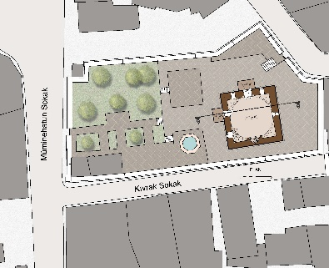
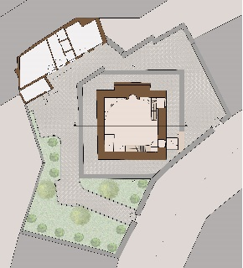
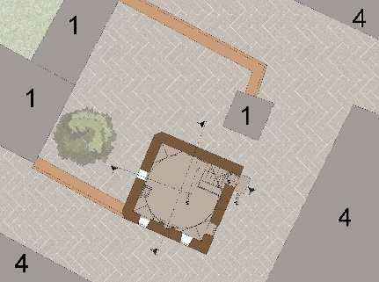

Figure 2. Masjid of Tercuman, Masjid of Sekerfurus, Masjid of Abdulaziz Plans

It is seen that 3 of the Seljuk mosque structures have two spaces. Although these masjids are discrete constructions, there is a garden with or without green spaces in their immediate surroundings. Most of the gardens are not sheltered (Figure 3).

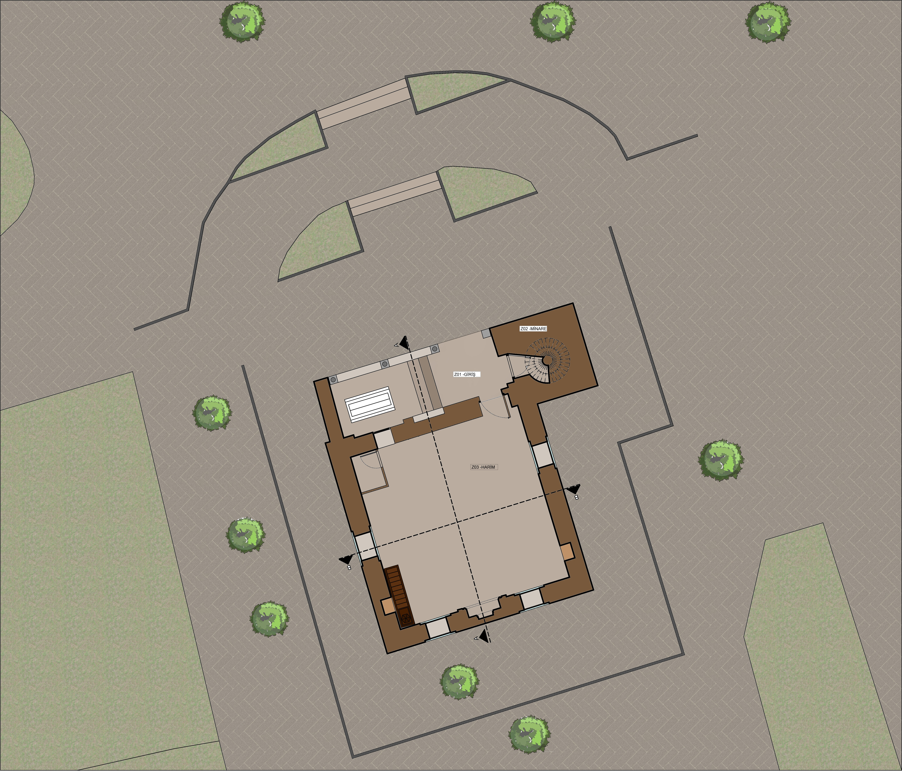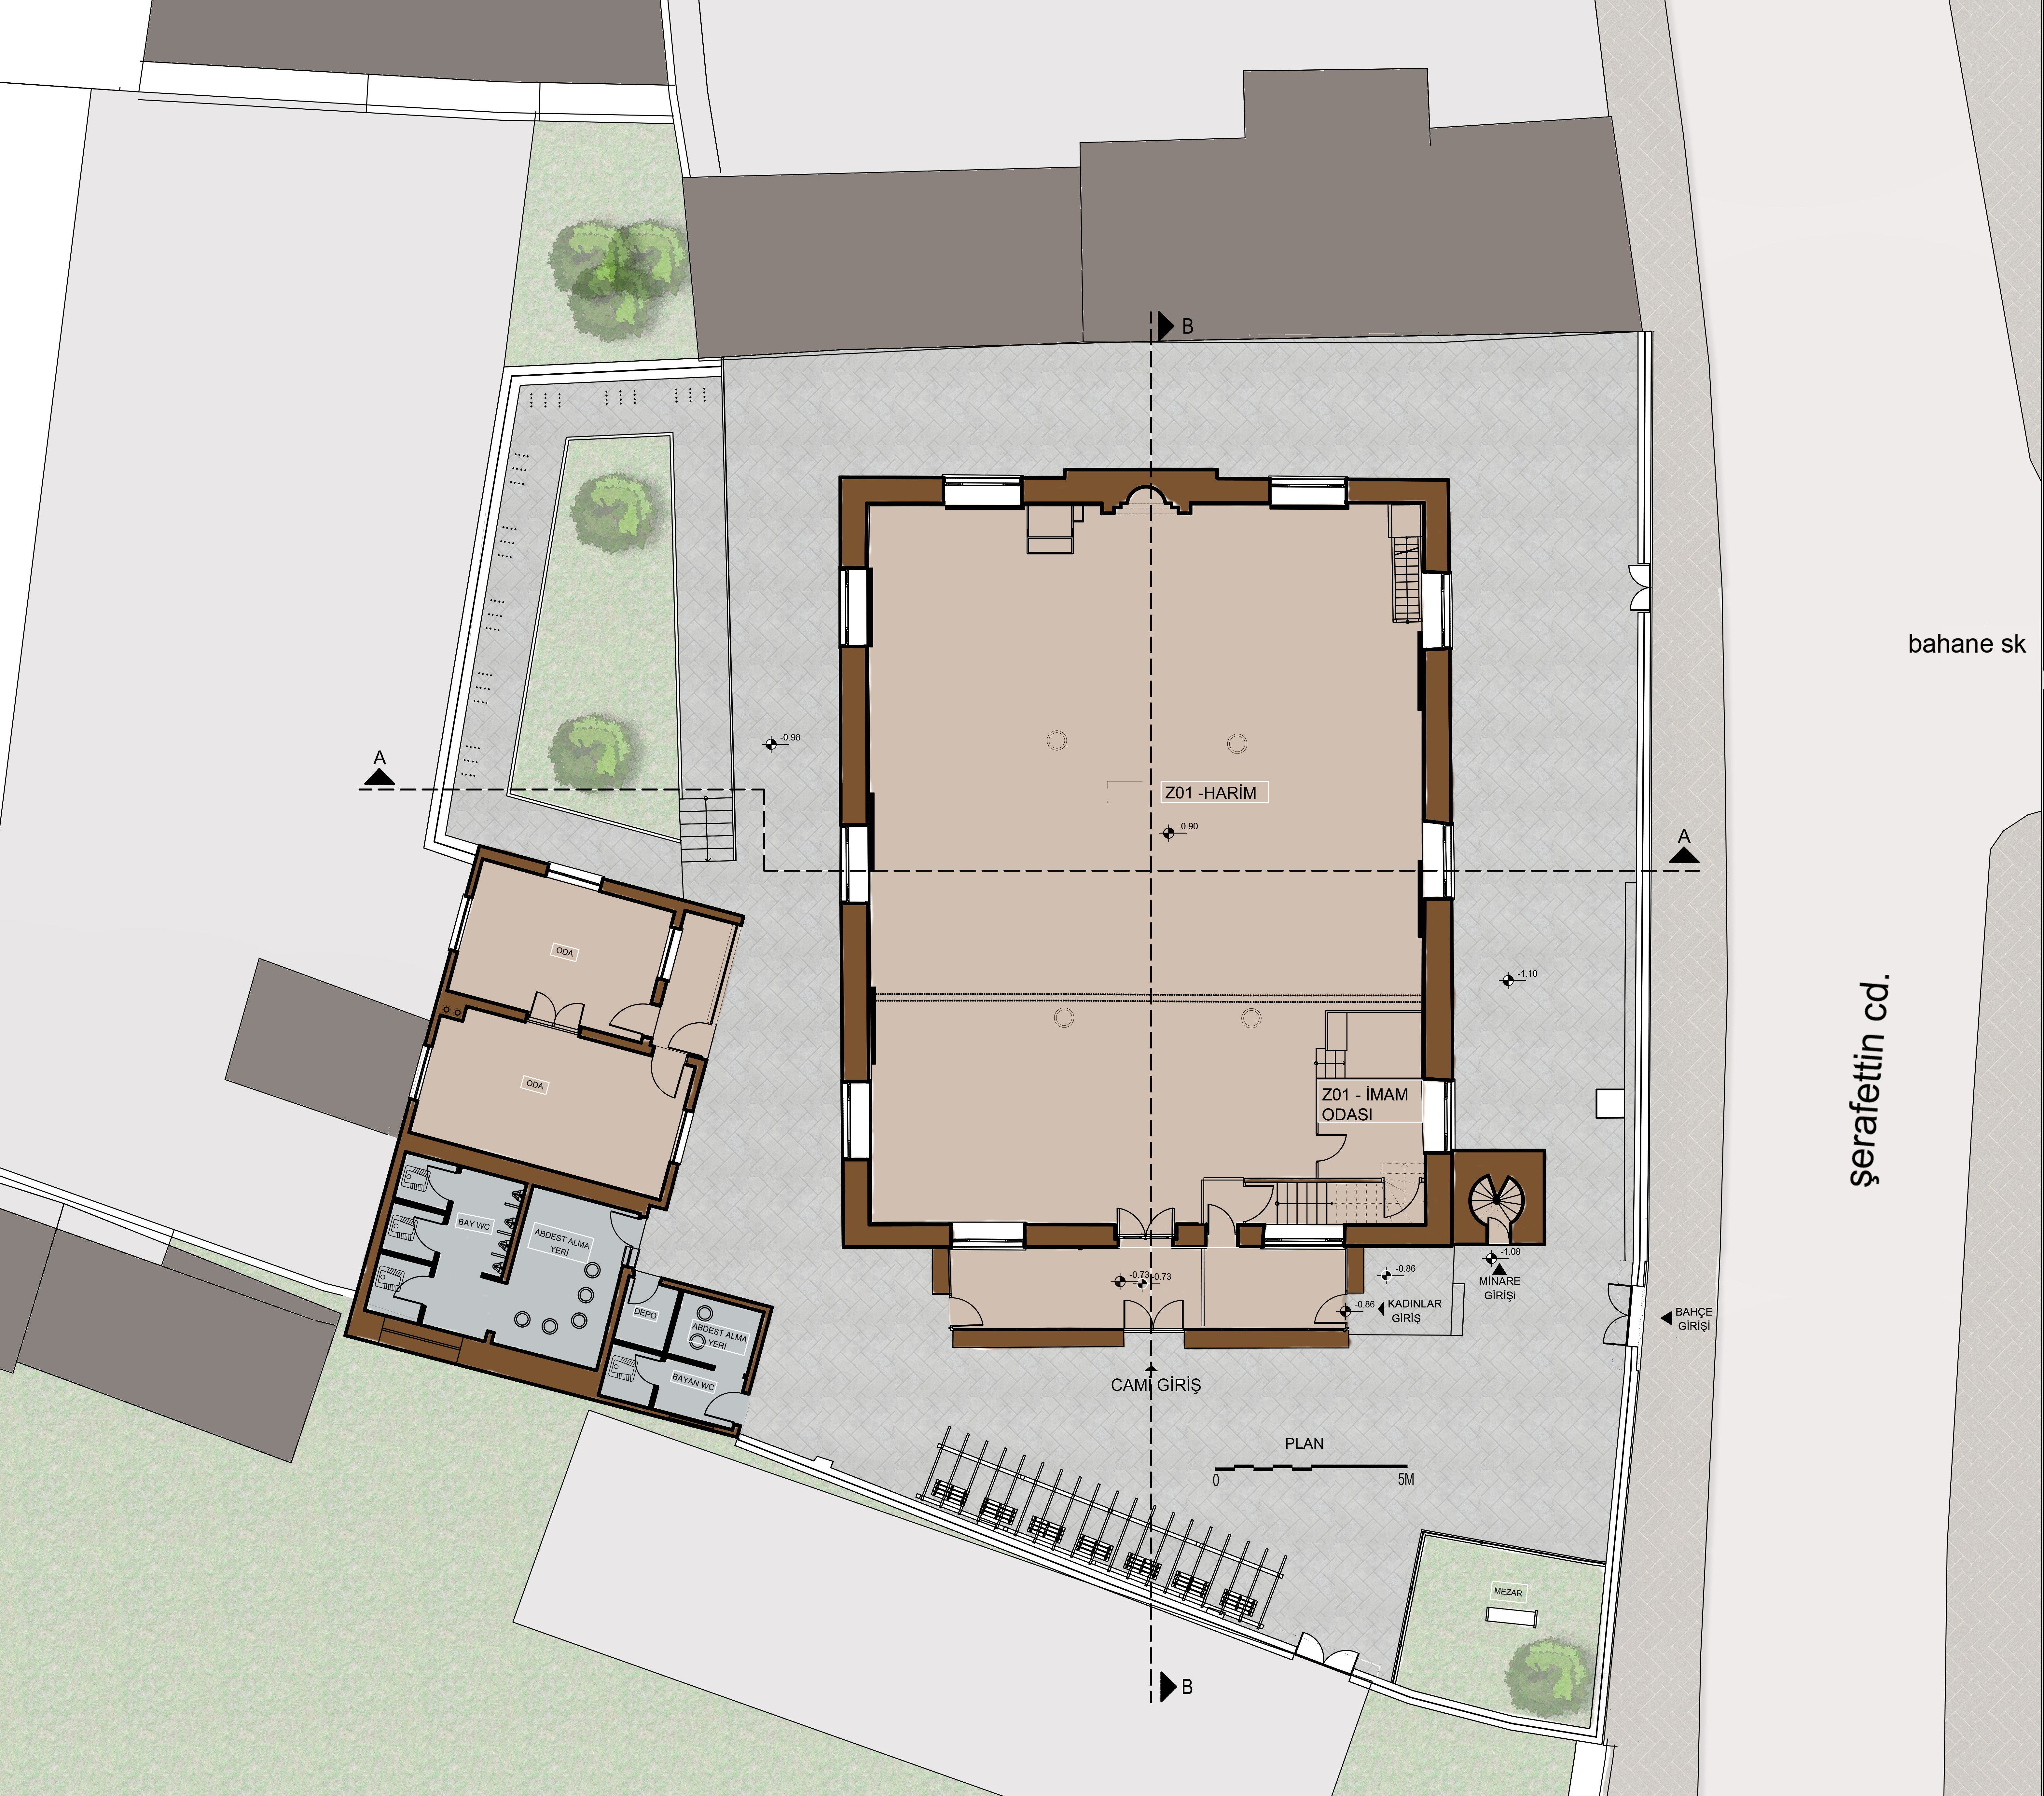

Figure 3. Hagia Hasan Masjid, Hodja Hasan Masjid, Kadi Izzettin Masjid Plans

It was found that 4 of the Seljuk mosque constructions had three spaces. Half of these masjids are discrete structures, while half are adjacent structures. There is a garden with or without a green area in the immediate surroundings of the buildings with discrete order. These gardens are open to the public. (Figure 4).
There is no overwhelming scale in the vicinity of the Serafettin and Selimiye Mosques, one of the classical Ottoman period buildings. These structures are in front of them, which define the spaces and main axes defined as squares. (Figure 5).

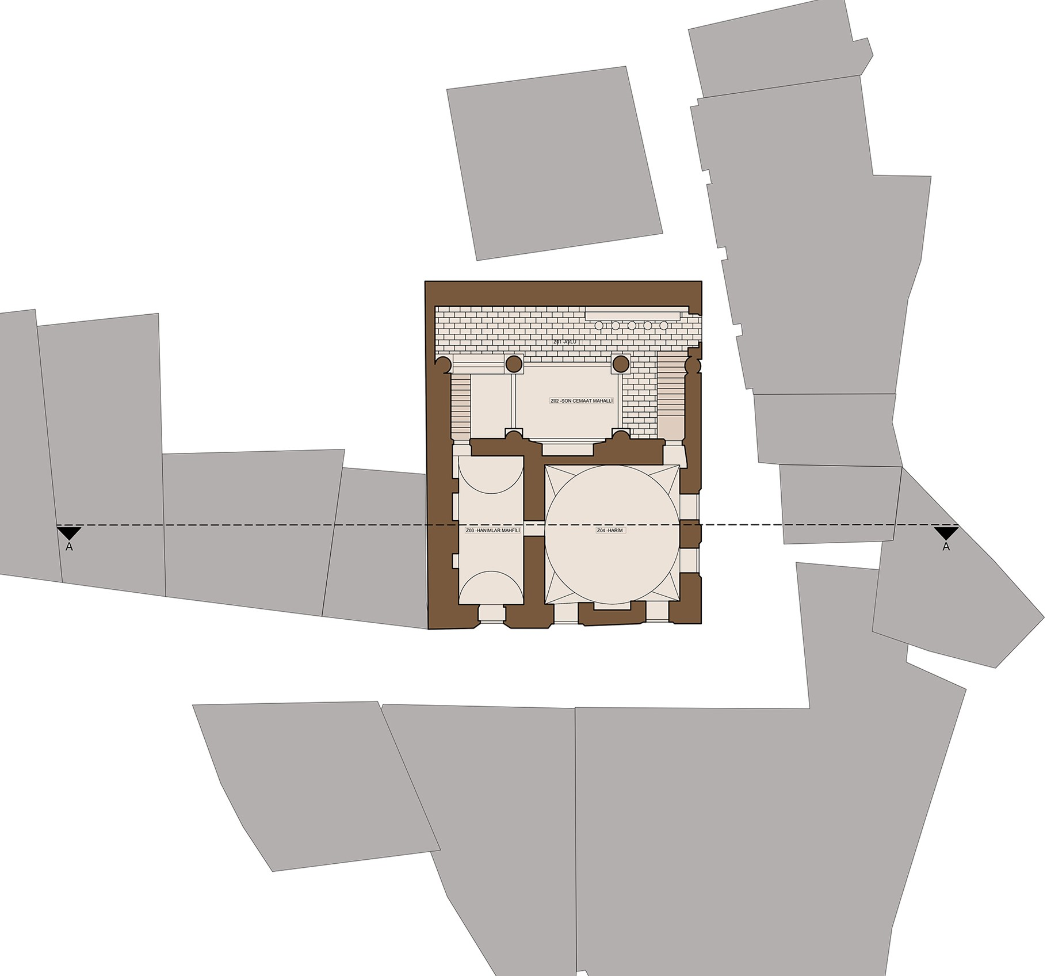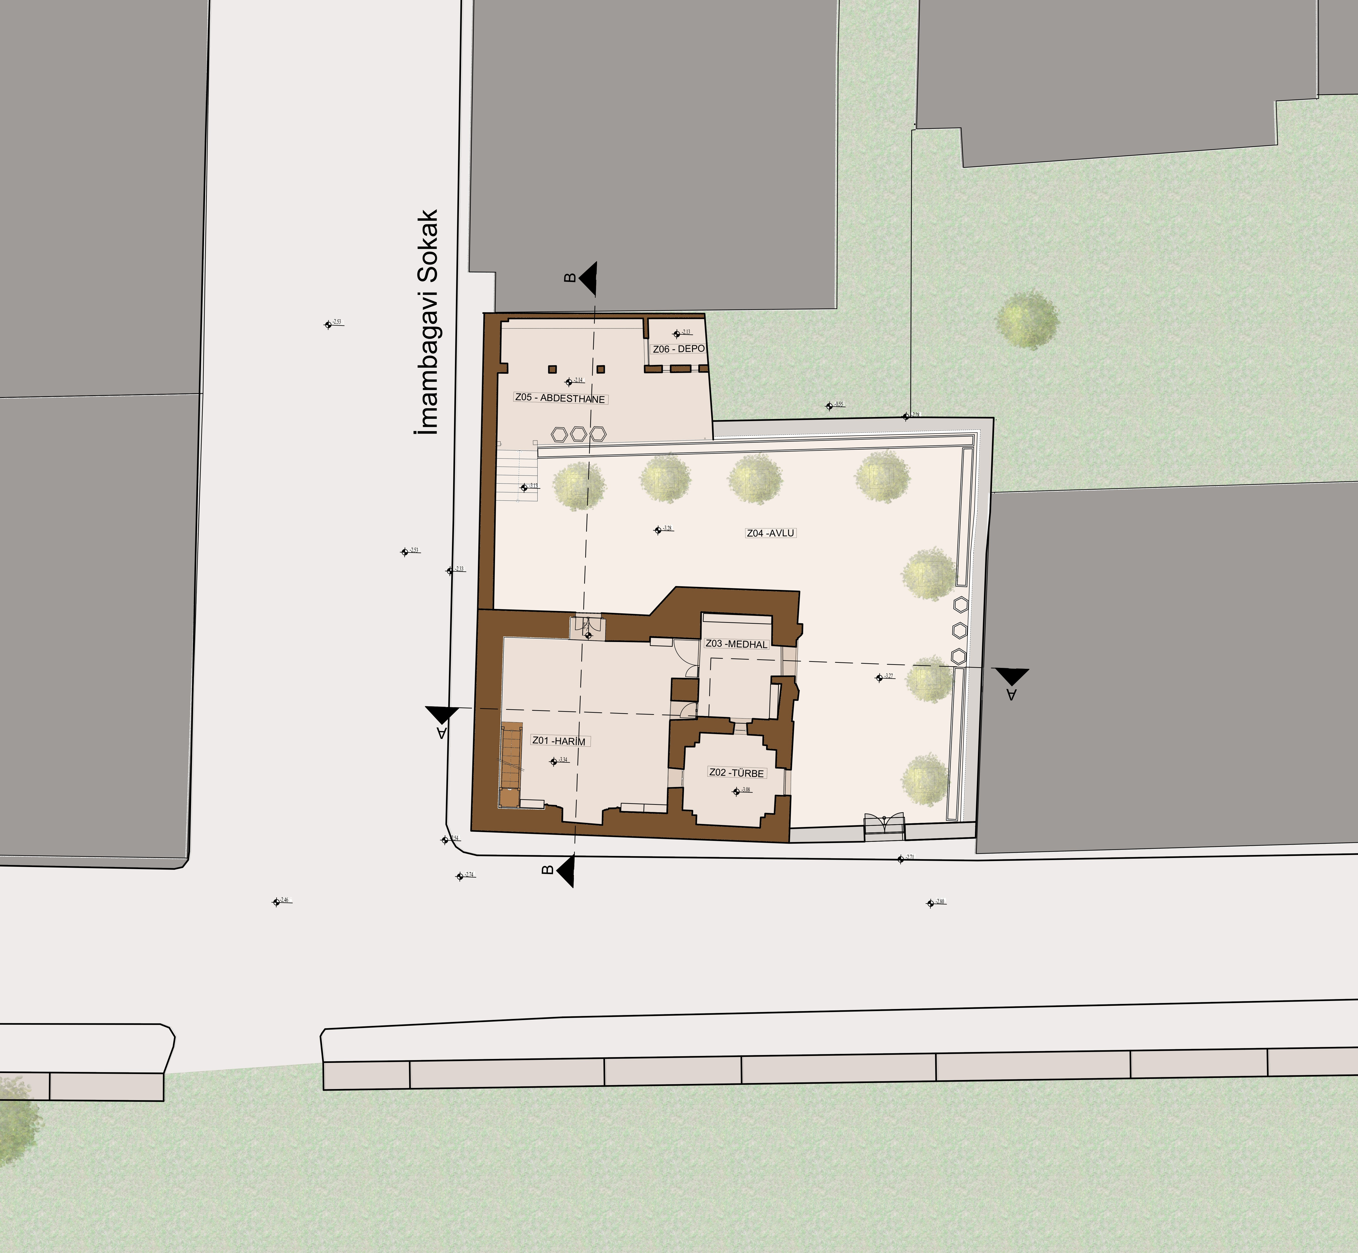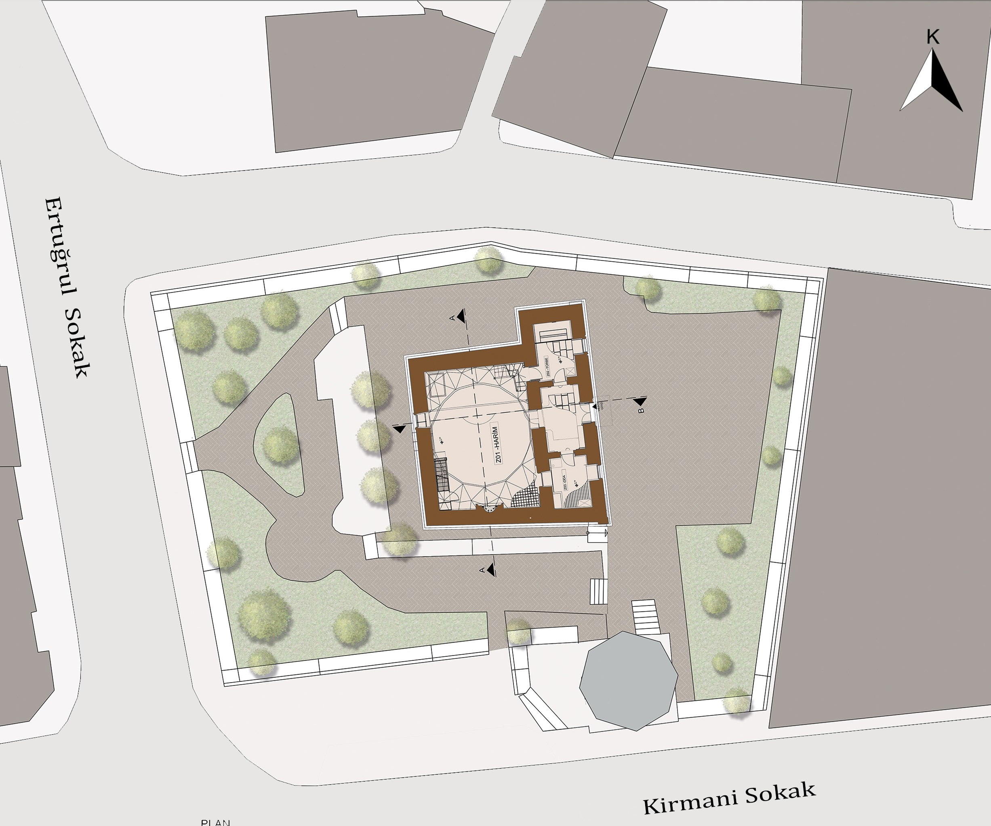

Figure 4. Beyhekim Masjid, Bulgur Tekke Masjid, Tahir and Zuhre Masjid Plans

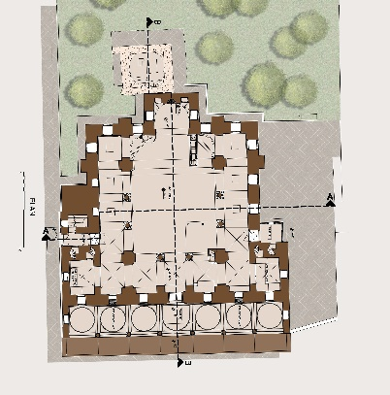

Figure 5. Serafettin Mosque Plan

Aziziye, one of the mosques of the late Ottoman period, has great splendor in terms of location, scale, texture, space and facade decorations. Like other Ottoman mosques, it is in a position defining the space in front of it (Figure 6).

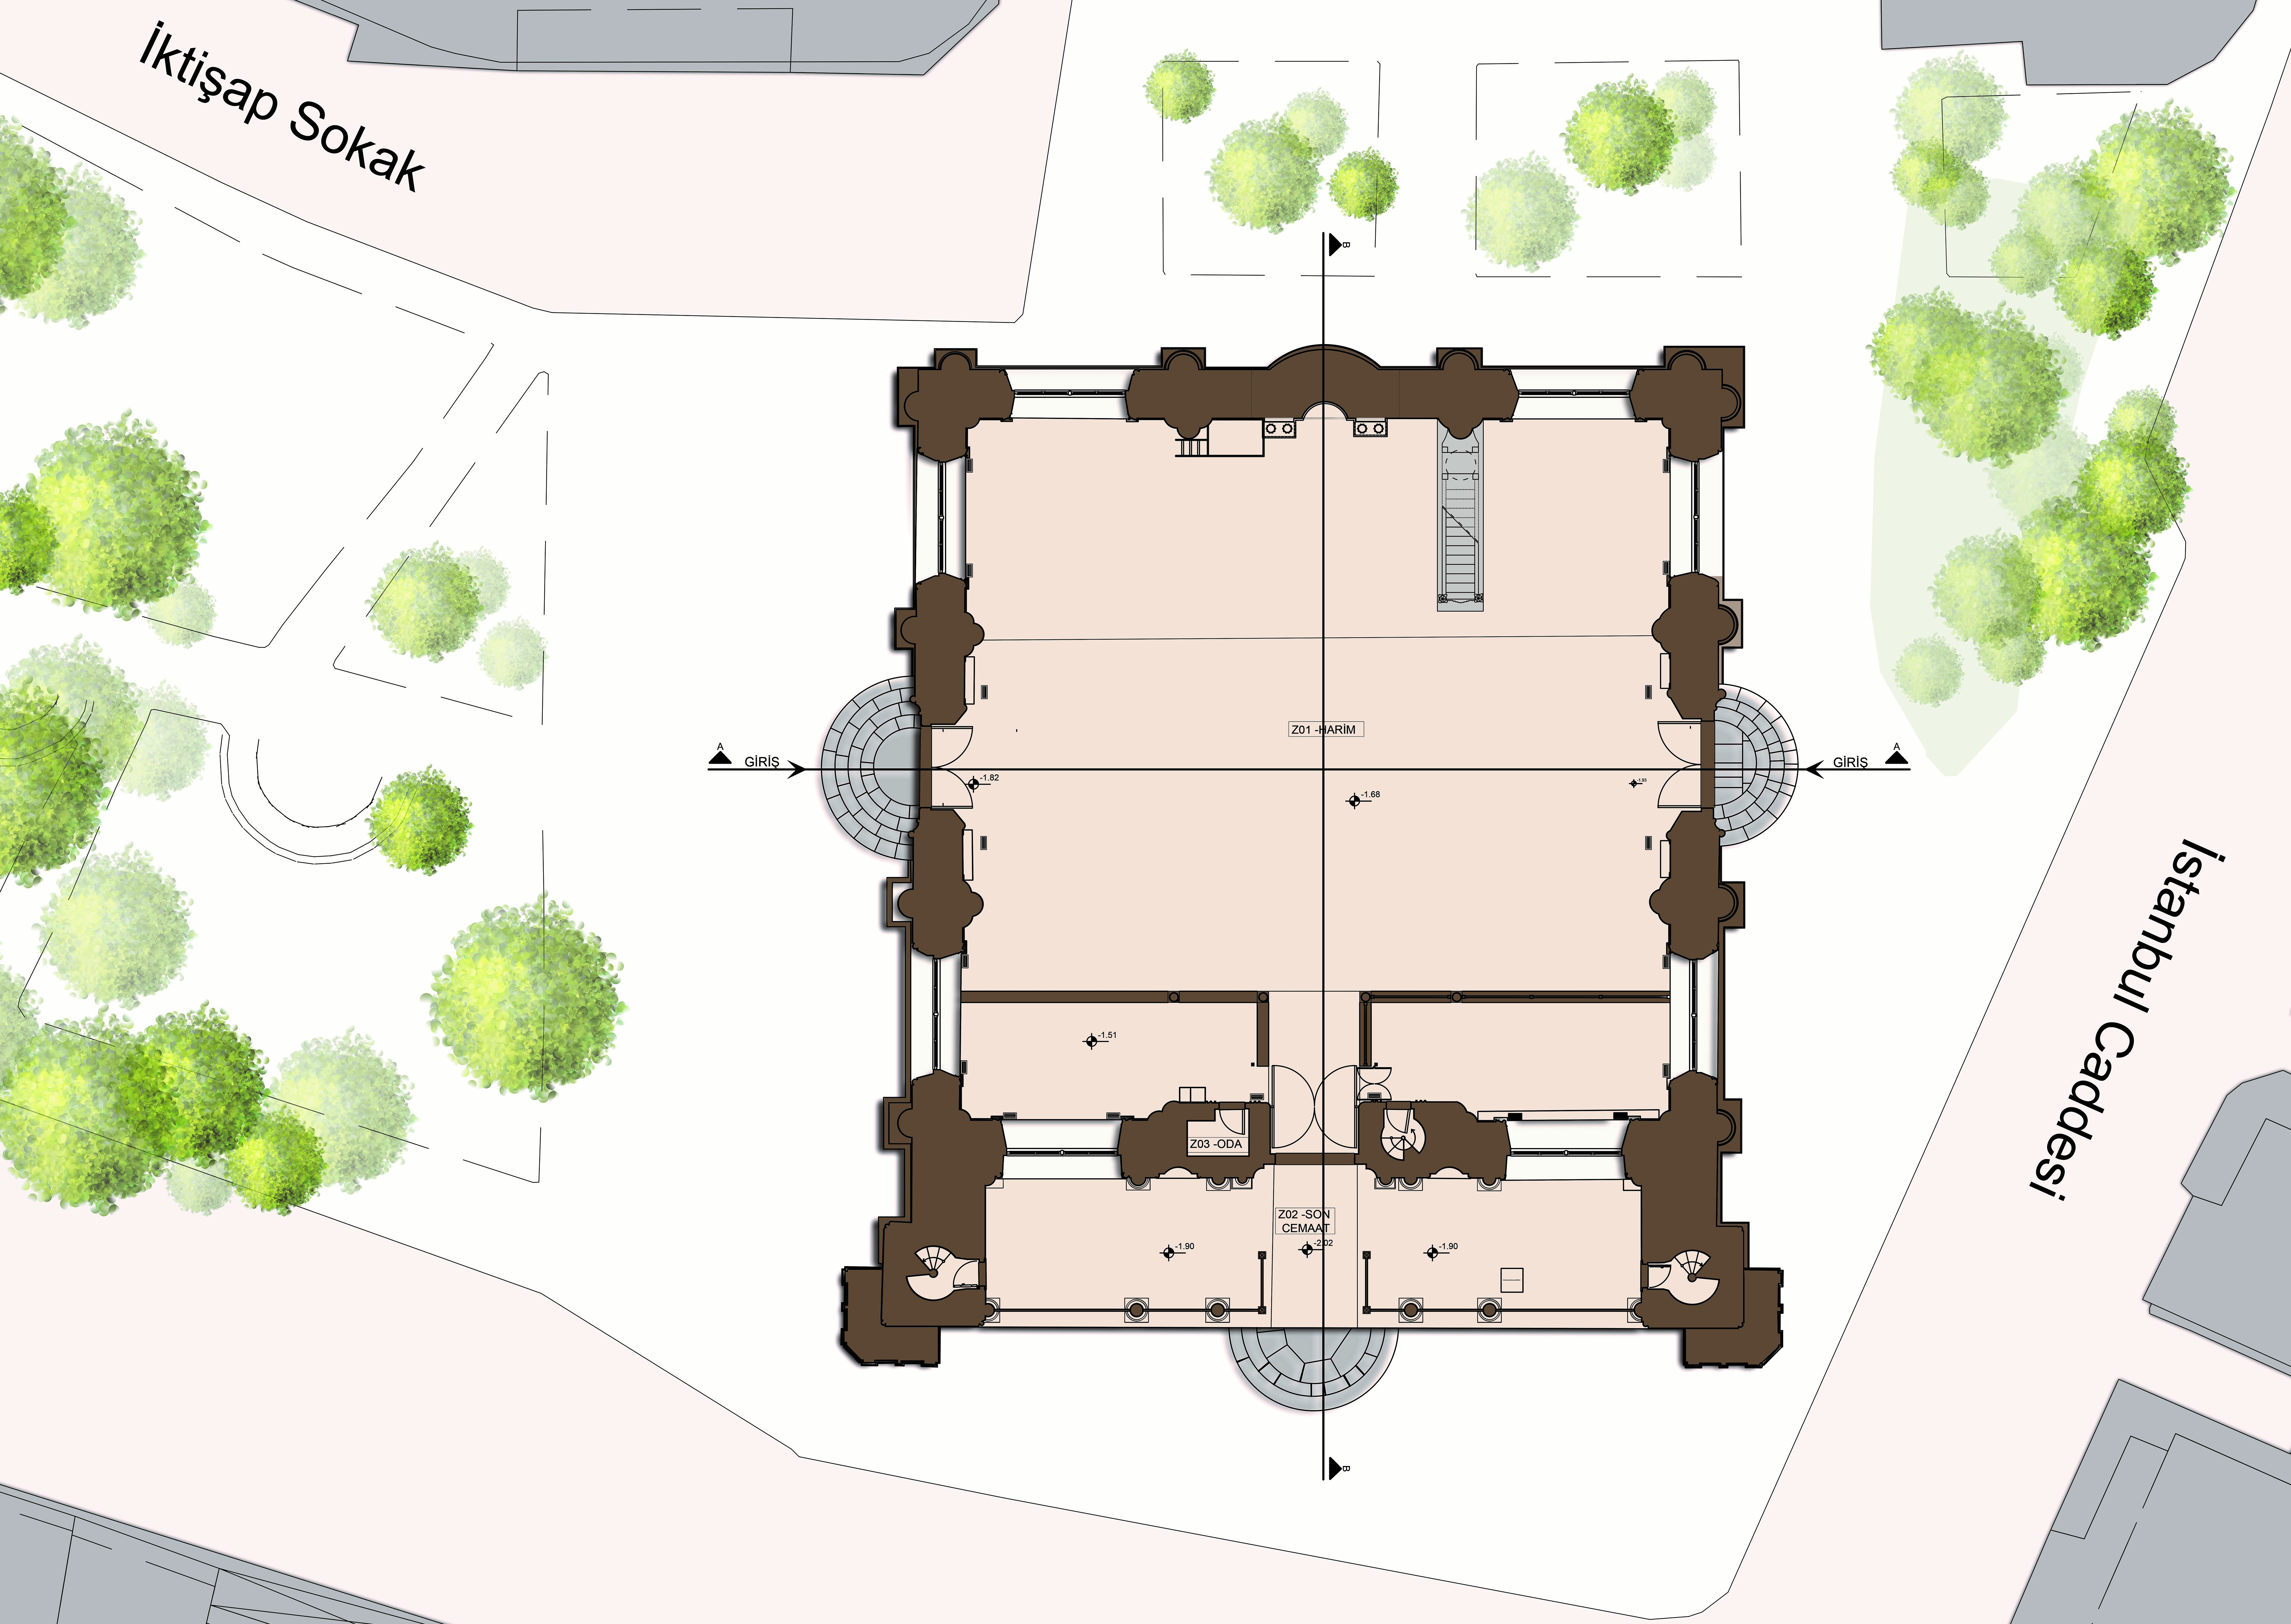

Figure 6. Aziziye Mosque Plan
When the mosque constructions are examined, it is seen that single-place masjids are covered with domes. 4 of the other masjids are covered with a broken roof while one is covered with a flat roof (Figure 7).

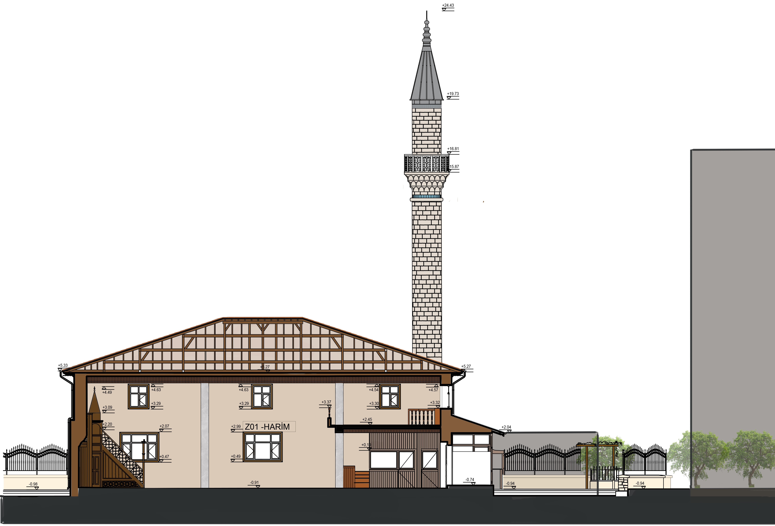

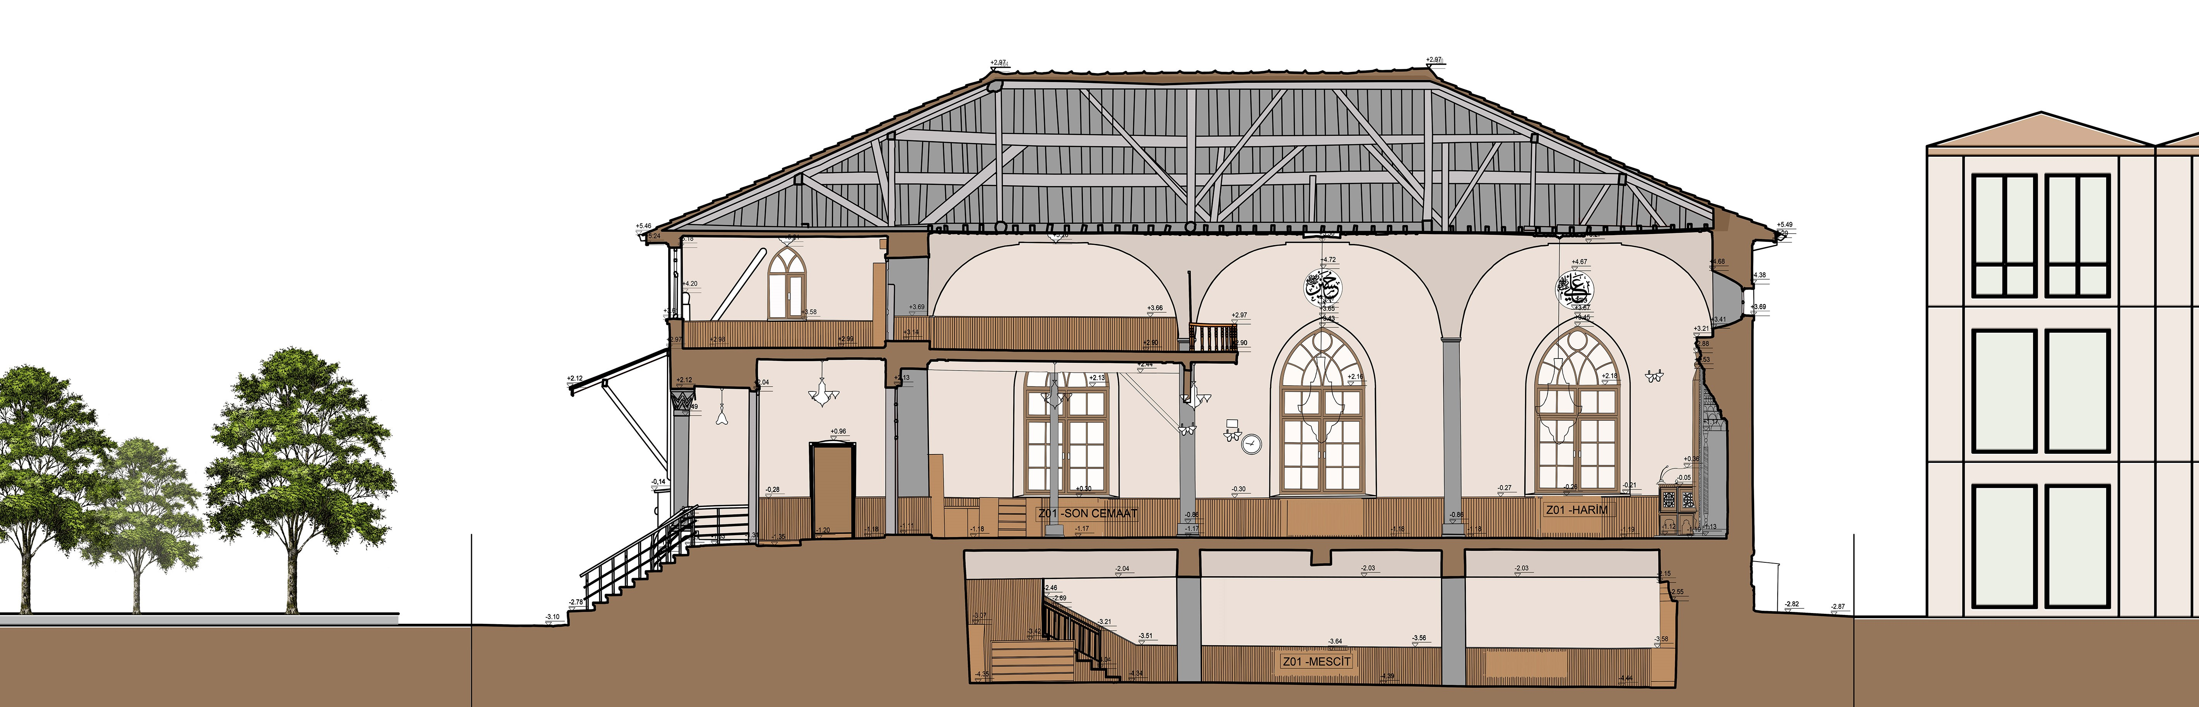

Figure 7. Hagia Hasan and Kadi Izzettin Masjids Cross Sections

During the transition from the Seljuks to the Ottomans, there was an increase in the facade cladding and decorations. When we look at the window ratios, the window ratios are 1/2 in 4 of the Seljuk mosques and masjids. Only Sahip Ata Mosque window rates are 1/1.5. The window rates in other Seljuk mosques are close to the square. In the Ottoman mosques, the window ratio is 1/2. Only Aziziye Mosque is the last period of the Ottoman structure because the window rates are growing 1/2.5.

5. CONCLUSION

In this study, the plans and sections of mosques and madrasahs belonging to the Seljuk and Ottoman civilizations determined in Konya were analyzed by processing the existing surrounding tissue. Design typologies have been determined in the light of the information in the literature and specific buildings.
When the plan schemes are examined, it is seen that 4 of the Seljuk constructions have square plans and 3 of them have rectangular plan schemes. Although the plan scheme of Alaeddin Mosque has a more organic plan scheme, it can be said to have been influenced by its topography. Although the Ottoman buildings have a central square plan scheme, they are much larger than the Seljuk mosque and masjid rates.
When the site plans were examined, it was observed that 6 of the constructions analyzed had a direct relationship with the street. It can be said that the scale of the buildings that have direct relations with the street is smaller than the other buildings. 3 buildings have their own garden with limited green area. The heights of the Seljuk mosques are directly proportional to their size. There are high-rise buildings in the immediate vicinity of the mosque. These constructions prevent sunbathing of the masjids.
Most of the Seljuk constructions are present, below the land or road elevation. It can be said that due to the increasing layers of roads and streets over time, the constructions remain below the road level. Most of the Seljuk buildings have a private area surrounded by walls, while there are also those who have direct contact with the street. Most of the Ottoman buildings are independent of their immediate surroundings.
When the cross-sections of the Seljuk and Ottoman structures were analyzed, it was seen that 8 Seljuks were flat-covered and 8 Seljuks were domed. All of the Ottoman buildings have a domed top cover. Only 2 Seljuk mosques have minarets. There are minarets in all the Ottoman mosques. It can be said that the Seljuk mosques were mostly single span. The size of the Seljuk mosques with windows close to the square is larger than other masjids.
As a result, the typological analysis of the identified structures supports the literature especially on Seljuk structures in Konya. Typical analyzes can be conducted comparatively in other cities where Seljuk constructions are located.
In addition, when the current situation of the identified structures is analyzed, changes should be made in the planning of the close environment of these constructions, which have the characteristics of cultural heritage, considering the presence of the Seljuk neighborhood masjids outside the outer castle. Most of the buildings are left open to visitors only for security reasons. The near-structuring should be rearranged in a way that these masjids will come to the forefront in scale and their security should be ensured throughout the day.

REFERENCE
[1] Baykara, T. (1998). Konya in Turkey Seljuks period. Konya: Ari publications.
[2] Duran, R., Apa G., Bozkurt T., Cetinaslan M. (2006). Konya book IX. Konya chamber of commerce new silkroad journal, 12, (236-241).
[3] Kuban, D. (2002). Anatolian art in the Seljuk period. Istanbul: Yapi Kredi publications.
[4] Karpuz, H. (2001). Anatolian Seljuk architecture. Konya: S.U. publications.
[5] Kuran, A. (1969). Anatolian madrasahs. Ankara: Middle East Technical University Press.
[6] Yilmaz, M. (2017). The golden ratio-aesthetic relationship in Seljuk period madrasas: The case of Konya (Master's thesis) Access address: https://tez.yok.gov.tr.
[7] Ozakin, R. (1998). Single-domed Seljuk mosques in Konya historical development, architectural features, VII. National Seljuk culture and civilization seminar. Konya: S.U. publications.
[8] Turan, S. (2018). Transition elements to the dome used in Turkish architecture; 13th century example of masjids of Konya neighborhood in Anatolian Seljuk period (Master's thesis) Access address: https://tez.yok.gov.tr.
[9] Caglar, S. (2018). The place of public buildings in social memory: The case of Konya city center (Alaeddin-Mevlana Axle) (Master's thesis) Access address: https://tez.yok.gov.tr.
[10] Bingol, O. (2007). Type concept and typology in architecture (PhD thesis) Access address: https://tez.yok.gov.tr.
[11] Yilmaz, S. (2018). Change process of housing typologies in Istanbul (Master's thesis) Access address: https://tez.yok.gov.tr.

Asst. Prof. Istanbul Sabahattin Zaim University, Department of Architecture, ISTANBUL
Asst. Prof. Istanbul Sabahattin Zaim University, Department of Interior Architecture and Environmental Design, ISTANBUL
Res. Assist. Istanbul Sabahattin Zaim University, Department of Architecture, ISTANBUL

