PART 1

Positioning of Turkey in Trade Wars between the USA and China

Dr. Ömer MURAT

International Trade Phd, Istanbul, Turkey

(ORCID ID: 0000-0001-9318-2154), omermurat@gmail.com

Dr. Tuğçenur EKİNCİ FURTANA

Istanbul Sabahattin Zaim University, International Trade and Finance Dept. Assist Prof.

(ORCID ID: 0000-0002-8495-9432), tugcenur.furtana@izu.edu.tr

Introduction

In the last years, the economic, financial, military, technological balance between the US and China has shifted rapidly in favor of China. It remains unclear what kind of relationship between China and the USA will be witnessed in the future. The reason why the issue is so on the agenda can be explained by looking at the recent history. In the post-cold war period, a unipolar world order was experienced under the leadership of the USA for a while, and then, with the strengthening of states such as Russia, the European Union and China, a multipolar world order was adopted. Military power called as hard power used in the cold war period has been replaced by commercial and economic power called as soft power which is masterly used by China.

Nowadays, where the welfare of countries depends on international trade, the fact that China takes over the leadership from the USA and that the USA spends most of its energy on sanctions against China also worries the third countries. Because it is feared that a possible strict polarization between these two superpowers will drag the world into a new cold war era. The fact that countries have to choose a side creates a very difficult situation considering the interdependence in international trade.

In this study, the historical development of the trade wars will be explained, and then the situation will be evaluated from the US and Chinese perspectives. China's new approach to international trade will be examined with the Belt and Road Initiative. Then, it will try to explain how positioning Turkey in the trade war.

1.1.The historical process of the Trade Wars
The U.S. merchandise trade deficit with China remains a major source of bilateral tension. From the US point of view bilateral trade imbalance as proof that China is not competing fairly in the global market (CRS, 2020, s. 1). The trade war started with the US investigation of Chinese goods in March 2018 is seen as a continuation of the protectionist activities that emerged as a result of the 2008 financial crisis.

The trade war between the two countries had begun with tariffs officially enacted on July 2018. And China’s Ministry of Commerce said in a statement that the United States “has launched the biggest trade war in economic history so far” (Swanson, 2018). However, the practices of the USA especially targeting China show that this war has some other important reasons besides the large foreign trade deficit against the USA. In May 2019, US President Donald Trump asked Google to cut support for the Android operating system for the Chinese technology company and Huawei phones, which have an important place in the smartphone market. This development is important in terms of showing the point reached in trade wars (Moon, 2019). Considering the developments in the international arena, it is seen that the reasons of the Trade Wars are not only due to the economic developments, but also the developments in the field of technology and the hegemony war between the USA and China in the global governance system.

It can be seen from table 1 that mutual trade sanctions were developed until 2020 after Trump used anti-China Propaganda in his Election Program. The first official sanctions are imposed in 2018 by the USA government. However, it can be seen from the table that China is not left behind, and responded to the USA with similar sanctions. This is the proof that the war takes place between equals. Trade wars do not end with the change of government and continue, it is also seen when Biden took over the management. The Biden administration has expressed a wish to discuss U.S.-China trade issues with its allies first (Hsu, 2021).

Table 1 Trade Wars Historical Process (2016-2020)

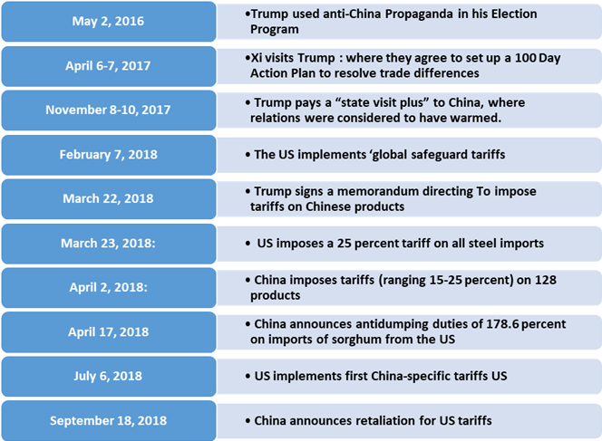
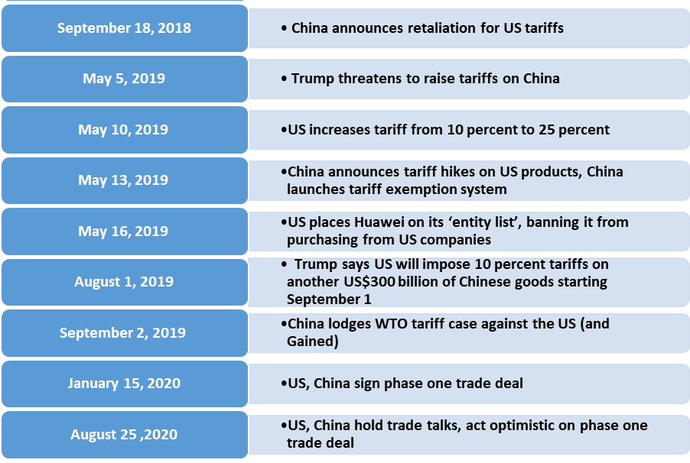
(Wong & Koty, 2020)

These protectionist sanctions made by USA against China (trade wars), are called protectionism and are rooted in mercantilism. Protectionism is based on Mercantilist ideas, whose origins date back to the 15th and 16th centuries. In Mercantilism, which is known as the first economic thought system, it was suggested that states should turn to export and stay away from imports as much as possible in order to strengthen their economies. In addition, bringing precious metals to the country through export is one of the most important rules of mercantilism. The idea of free trade emerged in England as a reaction to mercantilism. Protectionism and free trade actually appear as economic ideas that are applied interchangeably at certain times in the economy.

With globalization, free trade policies, which are especially defended by developed countries, are moving in the opposite direction with trade wars these days. The USA, known as the superpower of the world, is the main supporter of this war.
Periodically, Free Trade and Protectionism Applications
Period | Application | Period Features
1875-1914 | Free Trade | Golden money age and commercial liberalization & First period of  development in international trade
1914-1944 | Protectionism | War period, stagnation, depression, recession
1944-1970 | Free Trade | Institutional capitalism period, commercial liberalization, expansion  period in international trade
1970-1980 | New Protectionism | OPEC crisis, stagflation, recession period
1980-2000 | Free Trade | Neoliberal policies, multinational corporations, trade liberalization,  competition, non-tariff instruments, financial globalization
2008- | New Protectionism | Period of financial crisis and currency wars, new mercantilist / new protectionism era
Table 2 Periodically, Free Trade and Protectionism Applications
(Ünay & Dilek, 2018)

As can be seen from the table, the new protectionism period that started after the economic crisis in 2008 still continues. Countries referred to as developed economies, previously defending free international trade, they have turned their protectionist measures into the war today.

1.2.The Trade War from American Perspective

What the USA, the superpower of today's world, will do against China, which is confronted and growing gradually, is an issue that concerns the whole world. As the country that established the current world order, the USA refrains from obeying its own rules by seeing the conditions change against it. It tries to direct the terms of free trade in a way that suits its own interests. The USA creates an obstacle to the entry of goods into the country by raising the customs walls especially against Chinese goods. When China takes countermeasures, Trade Wars are taking place, affecting not only themselves but the whole world.

The US is trying to surround China on military, economic and human rights violations, as it did to the USSR with strategies from the cold war era. Because there is no sanction power left. However, China's economic relations with Asia Pacific countries, Russia and the EU have now become a deep interdependence. Even the weakening of China has come to the disadvantage of the USA due to the huge amount of US treasury bills and dollar reserves. The collapse of the US economy will also cause the dollar to depreciate, and it may cause trillions of dollars in loss to China. It is considered that it will be in the interest of both the new US President Biden and China to return their relations and policies to their normal formation by taking these results into consideration. In the figure below, it is seen that China is the largest creditor of the United States after Japan (1,251 trillion USD), with China's (1,072 Trillion USD) as of December 2020.

Figure X: The two largest countries to which the USA owes: Japan and China.
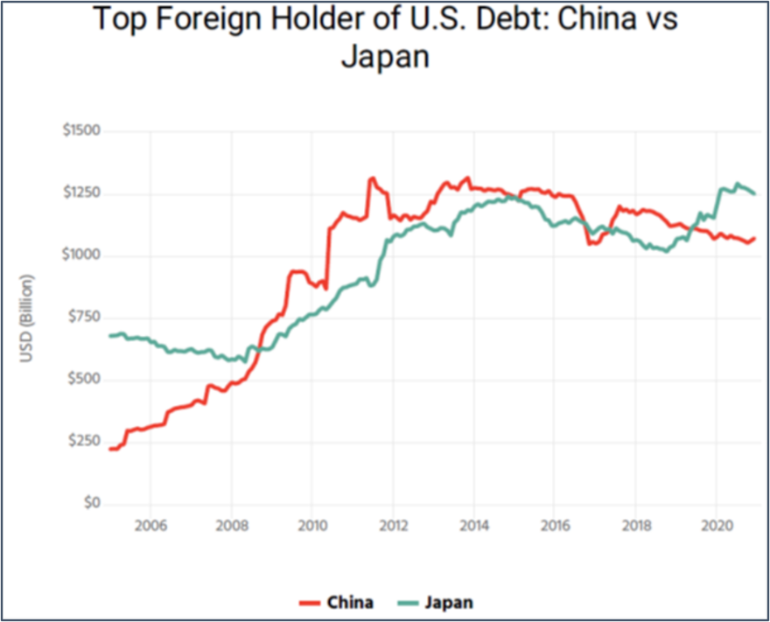
Source: U.S. Department of the Treasury (Duffin, 2021).

China, shown in Red in Figure X, has risen rapidly since the 2008 World Economic Crisis. However, the break from 2016 has increased even more in 2019 and Japan has turned into a larger creditor.

1.2.1. Change in the Global Balance of Power

The Asia Pacific region is now not only the most populous region in the world, but also the region with the largest economies. Researchers agree that this situation will shape the next century and a new economic balance of power will begin. The number of countries to consider when talking about the Asia Pacific region is four with the USA; others are China, India and Japan. South Korea, Russia and Australia are other important actors.

The Trans Pacific Partnership (TPP) negotiations were continuing successfully during the Obama period. Had the TPP entered into force as planned, a new giant economic formation would have been created with a large market in the Asia Pacific region, with the participation of two major capital-rich countries such as the USA and Japan. The main effect of this would be to reduce the dependence of the countries in the region on China and even take a step forward in the policy of containing China. Including preferential market access TPP, as well as strict rules in fields such as SOEs and competitiveness (Bown, 2021).
The world economy has evolved in a different direction after former US President Trump ignited trade wars and withdrew from the TPP in 2017.

China filled this huge gap by signing the Regional Comprehensive Economic Partnership (RCEP) Agreement in November 2020. India did not participate in the RCEP Agreement to protect its market and national interests. Hence, both the US and India isolated themselves at a stage where the future trade world was shaped.
The greatest benefit of international trade is that countries can achieve development and growth by buying and selling the goods and services they produce at affordable prices. Those who isolate their countries and expect benefits from partially Mercantilist policies see that they made mistakes in a short time.

Even though trade wars were identified with Trump, they were actually implemented in different methods during the Obama era. Trump has stepped out of previously finely crafted practices to reduce both foreign trade balance and unemployment. Trump reorganized the North American Free Trade Agreement (NAFTA) agreement, and left a very important regional agreement such as the TPP. Although it has gained political sympathy in the short term, statistical data show that the situation is not going well and the foreign trade deficit and unemployment rates continue to increase.

Although Obama frequently stated that he should turn his center of gravity to the Asia Pacific region, the concentrations centered on Israel and the Middle East caused the USA to fall behind in the Asia Pacific Region. With Trump's unpredictable policies, especially with the exit from TPP, a huge economic power gap has occurred in the region. It is seen that the new President Biden is aware of the necessity to re-establish trust with both EU and Asia Pacific countries and to re-determine economic rules with China.

US President Joe Biden said at the Munich Security Conference on February 19, 2021, that the transatlantic alliance is once again a priority for the United States. Biden repeated several times that "the US is back", reaffirming its commitment to NATO, its strongest link with Europe, one of its biggest trading partners. At the end of the speech, he noted that European partners should be ready for strategic competition with China in the long term (Biden, 2021).

1.2.2. USA's Increasing Deficit in Foreign Trade

President Trump, who promised to support American workers with the motto "America First" in his presidential campaign, clung to the policy of protectionism - withdrawal, in a way modern mercantilism. The withdrawal of the US from TPP and NAFTA regulation is also due to this. However, due to globalization and years of joint work such as the Global Value Chain (GVC), the trade wars between China and the USA have had global consequences. However, they suffered the most from this situation. Due to GVC connections, Asian economies such as Taiwan, South Korea and some ASEAN countries are most affected by the decline in China's exports to the USA, while the affected countries of the US side include Mexico, Canada and the Kingdom of Saudi Arabia (Holland & Cedric, 2019).

An important request by former President Trump to end the trade war was a reform of China's state-driven economic model, and particularly the "Made in China 2025 Plan," which denied America's competitive advantage. The main idea of Chinese academics and decision makers was to stick to the current development model, regardless of the pressure exerted by the US (Tang, 2019).
As a result of the foreign trade policies implemented by the US, as can be seen in the table below, although the import has increased gradually, the export has counted. Therefore, the deficit shown in green has increased gradually.

Table x: Foreign Trade Balance Table of the US and China for 2000-2020
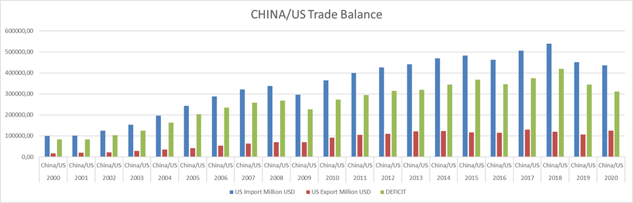
Source: Produced from the World Bank data.

Table X below shows the foreign trade data aimed by the customs barriers but realisation is not accordingly. It indicates that the US needs China more. We can see that Chinese imposed barriers more effective than the US.

Table X. The US and China: Threatened and imposed Trade war
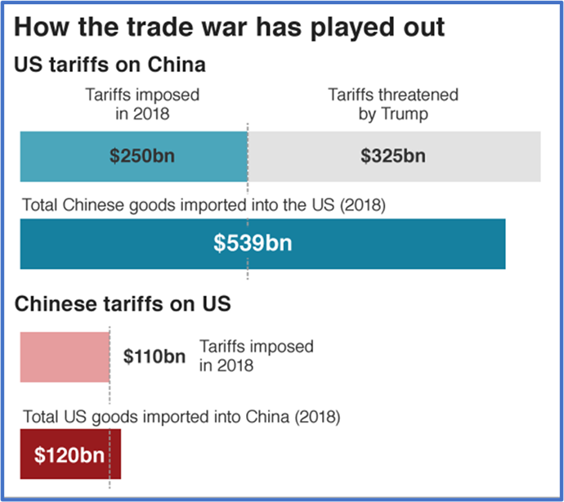
Source: US Census Bureau, BBC Research (8th March 2019).

1.2.3. Unfair Competition in International Trade

For the USA, China has attracted technology and production giants to its country by using its huge market and cheap labor. It transferred or extorted know-how from these companies in exchange for their benefits. It is unacceptable for the US to use anti-human rights policies, technology theft, especially high-IT-technology Chinese companies such as Huawei to take projects in exchange for bribery and send the confidential information they obtain to their country as intelligence (Maizland & Chatzky, 2020).

US and Chinese high-level officials have shared their expectations in their first meeting between the Biden administration and China in Alaska. The US side accused China of unfair practices, such as subsidizing industries, stealing intellectual property, keeping its currency low, and putting up barriers to trade. The Biden administration said it would be difficult on some alarming issues, but is willing to work with Beijing on key issues. However, he defined the relationship as a geopolitical rivalry between democracy and autocracy. The two-day China-US strategic dialogue in Alaska has come to an end tense and fruitless on 19th March 2021 (Plett-Usher, 2021) .

On March 20, 2021, the China Development High Level Forum started in Beijing. Former US Secretary of State Henry Alfred Kissinger attended the forum's first plenary meeting via videoconference. Kissinger explained that world peace and prosperity depends on the understanding between China and the United States. In the meeting, Kissinger pointed out that China and the US are two different great societies, and noted that there are differences of opinion between the two countries on some issues because of their different culture and history. He emphasized that this is the period of contemporary technology, science, global communication and economic globalization are rapidly developing. According to Kissinger, China and the US should make more efforts than before. "Because world peace and prosperity depends on the mutual understanding between China and the US" (CriTurk, 2021).

1.3. The Trade War from Chinese perspective

From a Chinese perspective, the point it has reached today is a great success. Whoever you take a competitor, you will compete with him. It is a plus fact that today US considers China as its rival. It is a great success that China, which had almost the same economic size as India in 1980 (BBC, 2021), is declared a rival by the USA today. Once seen as only a raw material supplier and a cheap labor-rich country, China has become one of the two largest economies in the world today.

In terms of its historical origins, China has been the raw material source of the industrializing countries of Europe, especially in parallel with the Industrial Revolution. And China tried to achieve its liberation from this situation with the Communist Revolution under the leadership of Mao. However, while it was observed that the Communist Revolution was not able to provide the development dynamics of China, these transformation efforts, which were also brought out within the Communist Party at the end of the 1970s, could have access to such rank as "Chinese Miracle" or "Factory of the World" (Yurttankaçmaz, Reziwanguli, & Emsen, 2020, s. 654).

Over the past 15 years, the change in economic and political balances between the US and China has accelerated. China's economic and political power in the international arena has increased. For example, China is now the largest economy in the world when measured in Purchasing Power Parity. When measured at market prices, the probability of taking the first place by exceeding the US within 10 years increases rapidly (BBC, 2021, s. 19).
The US economy grew by 4.2% in the last quarter of 2020, while declining at an annual rate of 3.5%. On the other hand, the Chinese economy continued to grow at 6.8% in the last quarter and 2.3% annually, demonstrating the difference between the two economies. China's share in total global exports increased from 5.9% in 2003 to 13.2% in 2019, while the share of the US decreased from 9.8% to 8.5% in the same tearm (Vasvani, 2021).

The discourse and activities of China towards the economic development and change of the international order in recent years pose a threat to the current situation of the USA. Among these are the RCEP, which it signed with Asia Pacific countries, and the CAI agreement with the European Union, as well as the Belt and Road Initiative, which it has developed and designed with a extraordinary system since 2013.
It may not be enough to explain trade wars solely for economic reasons. In the articles about trade wars in the Western public opinion, analysis that the USA has entered into this war especially for economic reasons stands out. However, according to the Chinese media and academic circles, the real reason for trade wars is that China opposes the hegemony of the USA with its economic and technological breakthroughs, and has a perspective that substitutes multipolarity instead of a unipolar world (Koçakoğlu & Özaydın, 2020, s. 643). In addition, it is seen that China's proposal for an alternative order against the liberal order has escalated this war.

1.4. New International Trade System and BRI

China, the world's second largest economy, has made great progress. With mega-regional aggreements China has a great impact on the world trade system. One of these agreements is RCEP, the largest Trade Agreement the world has ever witnessed, was signed on 15 November 2020 (Asean, 2020). Another is that the EU and China, in principle, completed the Comprehensive Investment Agreement (CAI) negotiations on 30 December 2020. These agreements are only examples on a large scale. But covering all these, The Belt and Road Initiative (BRI) targets China's main intention and the point it wants to reach.
BRI is a transcontinental long-term policy and investment program which aims at infrastructure development and acceleration of the economic integration of countries along the route of the historic Silk Road. The Initiative was unveiled in 2013 by China`s president Xi Jinping and until 2016, was known as OBOR – One Belt One Road (BRI, 2021). Although the announcement of the BRI was made in 2013, China started the preparations for this project much earlier, but did not announce it before it was fully ready, which is very in line with the Chinese state tradition.
In addition to this, China implements the BRI, which aims to reach the world economic resources and target markets and develop mutual trade, step by step. China's primary vision; It is the further development of its own country, increasing its welfare and achieving its future development goals.
OECD report defines BRI’s aim as :
‘China's Belt and Road Initiative (BRI) development strategy aims to build connectivity and co-operation across six main economic corridors encompassing China and: Mongolia and Russia; Eurasian countries; Central and West Asia; Pakistan; other countries of the Indian sub-continent; and Indochina’ (OECD, 2018, s. 3)
According to China's War book Sun Tzu, "an ingenious strategist defeats the enemy without fighting, seizes cities without siege". Today, there is no such war strategy in China. However, if we examine the subject in the context of international trade, we can see that the Chinese leaders surrounded the modern world with a different strategy, with the advice they received from their ancestors. Acting with the understanding that it is best to win without fighting, China makes its struggle through the dependence of the countries it produces and exports to. The point China has reached today shows that the Chinese Dream will go further (Ekinci Furtana, 2021, s. 20).
China opens a window to a different future with its tendencies to facilitate international trade, which it has developed with BRI. The translation of the name OBOR into initiative has a separate and meaningful meaning. ‘The initiative’ can be interpreted in two ways. First, China semphasizes that it has taken the initiative to change and improve the international trade system with BRI. Second one is that however, during the cold war the USA provided unpaid monetary support with Marshall Aids, China can be interpreted as preferring to take the initiative in return for loan. And this situation can also be called business diplomacy.
China, with BRI, especially focuses on collaboration, cooperation priorities 1. Policy coordination (Promotion of intergovernmental cooperation, multi-level intergovernmental macro policy exchange and communication mechanism) 2. Facilities connectivity (Improvement of connectivity of infrastructure construction plans and technical standards systems) 3. Unimpeded trade (Reduction of investment and trade barriers, promotion of regional economic integration) 4. Financial integration (Coordination and cooperation in monetary policy, set-up of financing institutions) 5. People-to-people bonds (Cultural and academic exchange and dialogue, media cooperation) defines like that in BRI explanations (BRI, 2021).

Table 3 BRI Corridors
1 | NELBEC | New Eurasian Land Bridge Economic Corridor
2 | CMREC | Mongolia – Russia Economic Corridor
3 | CCWAEC | China – Central Asia – West Asia Economic Corridor
4 | CICPEC | China – Indochina Peninsula Economic Corridor
5 | BCIMEC | Bangladesh – China – India – Myanmar Economic Corridor
6 | CPEC | China – Pakistan Economic Corridor
(BRI, 2021)
The Silk Road Economic Belt has 6 corridors on land routes. Beside BRI includes The 21st Century Maritime Silk Road and The Polar Silk Road. The passageways of these corridors are provided by multi-dimensional corridors in the direction of Asia Pacific instead of a single route. BRI is a strategic economic belt that includes the South China Sea, Pacific Ocean and Indian Ocean (Yılmaz, 2019, s. 12).
In particular Turkey; As a result of the problems with the USA and some EU member countries, the problems that have moved away from the solution have led to the search for alternatives in foreign policy.

In line with this thought that Chinese investments will also serve the interests of both sides, and is considered to be beneficial for Turkey. China, as part of a much larger plan is to see Turkey. In terms of Turkey, the situation is currently limited only economic support, credit collaborations and investment.
While the effects of the Trade Wars between the USA and China on the world economy continue, China has managed to get out of the way, despite the loss of power in the EU and the USA with the COVID 19 pandemic. While other world states are struggling with the pandemic, China continues its trade, infrastructure development activities and continues its leadership with agreements such as RCEP, CAI, BRICS and Shanghai Cooperation Organization. The European Union has given the best example of being a Union in the world among supranational states. Today, it is seen that China is trying to create its own associations by taking this as an example.
Turkey due to its production base in both a geographical position between Europe and Africa region has commercial advantages. Being a country of Customs Union with the EU, having a developed transportation infrastructure and a large trained manpower resource creates a suitable environment for foreign investments. Along with investments, it is also possible to have new production opportunities and new export products through employment and know-how transfer.

In this context, due to its geopolitical position in line with the objectives of China, Turkey is a strategic country. Turkey, not only geographically, but also for the global Chinese companies have the potential to be an ideal regional centers. Turkey's influence in the region will create and play an important role in the development of BRI.

1.5 Positioning Turkey in the Trade War

Turkey entering the Customs Union in 1996, has taken an important step towards the EU Associate Membership. After this stage, the FDA to Turkey increased at a higher rate. Learning about the competition, the Turkish industry has achieved successful results in exports and started to make half of its exports with the EU in its foreign trade. Turkey's largest trade partner in the region is EU countries. Turkey's tourism sector particularly attractive destination in the world for EU and Russian tourists.

Turkey re-assessed the changing balance of the world. In order to continue its economic development, it makes economic cooperation not only with the West but also with China and Russia. Turkey's first nuclear power plant, according to the agreement signed with Russia on construction, plant construction continues. In the defense industry, purchases have been made, especially the S-400 air defense system. Turkey is an important part of China's BRI project. China's railway system connected to London via underway of the Bosphorus. The economic relations with Qatar in the Middle East, continue to provide mutual benefits to the parties. Efforts to establish a similar trade relationship with Israel and Egypt regarding natural gas and oil deposits in the Eastern Mediterranean basin are continuing. Natural gas deposits in the Black Sea will make a positive impact on Turkey's energy system and the foreign trade balance will be positively affected. On the other hand, in 2020, the COVID-19 Pandemic disrupted international trade and tourism.
The trade wars declared by the US against China only limited the trade with each other to a certain extent, but it continues. In trade between the US and Turkey continue to increase in the same way. Because of COVID-19 pandemi effects, most of the countries shrunken in 2020. But with the help of their production based economic structure, Turkey and China have completed the year with slight growth.
The US is in search of countries that will shift its imports from China. India is the most available country in this regard. However, GVCs cannot be changed in a short time. India needs at least 10 years to replace China. Turkey is also one of the most important potential production bases in this period.

The US prevented the EU applying sanctions on Turkey during March 2021. Turkey is a vital part of the West Economic system, eventhough there are some different ideas. Having Customs Union Agreement with the EU, Turkey is the EU candidate country. EU goods exports to Turkey in 2019 fell by 1.3% to €68.2bn, while imports from Turkey rose by 4.4% to €69.8bn (European Commission , 2020).

The EU, on the other hand, is a huge market for Russia, China, and the USA worldwide. Turkey's industry gained a competitive experience because of the challenge of the Customs Union starting from 1996. Similar scenario will run against China and Asia Pasific Countries products. In order to keep innovation and focusing on value-added products in this market is essential for Turkey. With the help of the FTAs with South Korea, Malaysia and Singapur, Turkey can be a part of RCEP. There can be different solutions of being part of the GVCs in the region.

Conclusion

As the US developed its economy during the colonial period when African people brought their labor force to their country as slaves, in the 21st century it reached more humane and relatively cheap manpower with the help of China. No one expected China to come to these days by ruling such a large population with a Communist regime and a liberal logic. In fact, in the 1980s, one of the fears of the developed countries of the world was how they could overcome the chaos that would arise due to the collapse of the Chinese administration and Chinese people going to various countries of the world as refugees. It is considered that the new cheap worker target of the USA will be India and Asia Pacific countries. As Kissinger stated, the road to world peace and prosperity is the path of cooperation. Countries belonging to different cultures, such as the US and China, have to find a middle way to understand each other.
Turkey should continue to develop its cooperation with the EU. It should continue on its way patiently, like China, in this regard. It will determine its direction according to its own interests with the decisions to be taken when the appropriate time and conditions occur. It should improve his position in the BRI. On the way back to China, steps should be taken to fill the containers of the trains and to develop trade and tourism with the route countries. The medical infrastructure developed for COVID-19 should keep on developing, then be prepared for future diseases. It has been observed that countries with the vaccine can be a guide and orient in terms of international trade.
Turkey, in this trade war era, should educate and train its “Trade Warriors”. These trade warriors, with the Turkish brands they represent, should strengthen the image of "Made in Turkey". The manufacturing power of Turkey should be focused on export and should become an orienting the market. Turkey's defense industry achievement should be created for commercial life too. With the know-how gained in the defense industry, R&D and P&D centers should be supported in order to develop new products for consumers. Steps should be taken to develop regional trade agreements. It should help it become an indispensable country of global value chains. Turkey, which has become a production base in the region such as China, having an eco-system connected to it should do its best to be a country open to FDI.

References

Asean. (2020). ASEAN Hits Historic Milestone with Signing of RCEP. https://asean.org/asean-hits-historic-milestone-signing-rcep/ adresinden alındı
BBC. (2021, 03). Rekabetleriyle Geleceği Şekillendiren İki Süper Güç ABD ve Çin- BBC Raporu . Turk Diplomatique.
Biden, J. (2021, 02 19). Munchen Securtiy Conference 2021. https://securityconference.org: https://securityconference.org/en/medialibrary/asset/a-new-transatlantic-agenda-part-i-joe-biden-angela-merkel-emmanuel-macron/ adresinden alındı
Bown, C. (2021). The US-China Trade War and Phase One Agreement. Washington, D.C.: Peterson Institute for International Economics.
BRI. (2021). Belt and Road Initiative. https://www.beltroad-initiative.com/belt-and-road/ adresinden alındı
CriTurk. (2021, 03 20). Kissinger-dunya-barisi-ve-refahi-cin-ve-abdnin-birbirini-anlamasina-bagli. https://www.criturk.com: https://www.criturk.com/kissinger-dunya-barisi-ve-refahi-cin-ve-abdnin-birbirini-anlamasina-bagli adresinden alındı
CRS, R. (2020). What’s the Difference?—Comparing U.S. and Chinese Trade Data. Congressional Research Service. https://crsreports.congress.gov/ adresinden alındı
Duffin, E. (2021, 02 24). Foreign holders of the US Treasury Debt. www.statista.com: https://www.statista.com/statistics/246420/major-foreign-holders-of-us-treasury-debt/#:~:text=Of%20the%20total%207.07%20trillion,countries%20and%20Caribbean%20banking%20centers. adresinden alındı
Ekinci Furtana, T. (2021). Çin, Kuşak Yol İnisiyatifi Türkiye'nin Uluslararası Ticaretine Etkisi. İstanbul: Avrasya Stratejik Araştırmalar Merkezi Yayınları.
European Commission . (2020, 05 20). https://ec.europa.eu/trade/policy/countries-and-regions/countries/turkey/ adresinden alındı
Holland, B., & Cedric, S. (2019, 05 28). "A $600 Billion Bill: Counting the Global Cost of the U.S.-China Trade War." Bloomberg. https://www.bloomberg.com: https://www.bloomberg.com/graphics/2019-us-china-trade-wareconomic-fallout/ adresinden alındı
Hsu, S. (2021). The US-China Trade War Is Still Happening. The Diplomat: https://thediplomat.com/2021/03/the-us-china-trade-war-is-still-happening/ adresinden alındı
İMMİB. (2020). Trans-Pasifik-Ortaklik-Anlasmasi-CPTPP. https://www.immib.org.tr/tr/duyuru-haberler-trans-pasifik-ortaklik-anlasmasi-cptpp-hk.html adresinden alındı
Koçakoğlu, M. A., & Özaydın, A. (2020). Yeni Korumacılık: Ticaret Savaşı mı? Elektronik Sosyal Bilimler Dergisi, 19 (74), 630-646.
Maizland, S., & Chatzky, A. (2020, 08 06). Huawei-chinas-controversial-tech-giant. https://www.cfr.org: https://www.cfr.org/backgrounder/huawei-chinas-controversial-tech-giant?gclid=Cj0KCQjwmIuDBhDXARIsAFITC_7Qe83vrxEfbzlPhyasx8Cyl8e1ycCgfhwvCnVy4HXQggTklMREWI8aAnnQEALw_wcB adresinden alındı
Moon, A. (2019). Exclusive: Google Suspends Some Business with Huawei After Trump Blacklist. Reuters. 03 10, 2021 tarihinde https://www.reuters.com/article/us-huawei-tech-alphabet-exclusive-idUSKCN1SP0NB adresinden alındı
OECD. (2018). China’s Belt and Road Initiative in the Global Trade, Investment and Finance Landscape. https://www.oecd.org/finance/Chinas-Belt-and-Road-Initiative-in-the-global-trade-investment-and-finance-landscape.pdf adresinden alındı
Plett-Usher, B. (2021, 03 19). US and China trade angry words at high-level Alaska talks. https://www.bbc.com: https://www.bbc.com/news/world-us-canada-56452471 adresinden alındı
Swanson, A. (2018, 07 05). Trump’s Trade War With China Is Officially Underway . NY Times: https://web.archive.org/web/20180712201844/https://www.nytimes.com/2018/07/05/business/china-us-trade-war-trump-tariffs.html adresinden alındı
Tang, F. (2019, 07 13). "China ignoring US demand for trade war reform by reinforcing state-directed economic model.". https://www.scmp.com: Tang, Frank. "China ignoring US demand for trade war reform by reinforcing state-directed economic model." https://www.scmp.com/economy/chinaeconomy/article/3018120/china-ignoring-us-demand-trade-war-reform-reinforcing-stater adresinden alındı
Ünay, S., & Dilek, Ş. (2018). Yeni Korumacılık ve Ticaret Savaşları. İstanbul : SETA- Siyaset, Ekonomi ve Toplum Araştırmalar Vakfı Yayınları .
Vasvani, K. (2021). Covid-19: China's Economy Picks up, Bucking Global Trend Bucking Global Trend. BBC: https://www.bbc.com/news/business-55699971 adresinden alındı
Wong, D., & Koty, A. C. (2020). The US-China Trade War: A Timeline. China Bbriefing: https://www.china-briefing.com/news/the-us-china-trade-war-a-timeline/ adresinden alındı
Yılmaz, S. (2019). Bir Kuşak Bir Yol Projesi . Ankara: Astana Yayınları .
Yurttankaçmaz, Z. Ç., Reziwanguli, Y., & Emsen, Ö. S. (2020). Çin ile ABD Arasında Ticari Gerginlik: Rekabet Gücü Açısından Bir Bakış. Atatürk Üniversitesi İktisadi ve İdari Bilimler Dergisi( 34(2) ), 649-667.

Details are abbreviated and summarized, you can check the link in the reference for more.
Upon the withdrawal of the USA without signing the TPP Agreement, 11 countries that changed the name of the agreement to the Comprehensive and Progressive Agreement for Trans-Pacific Partnership(CPTPP) signed it in Chile on 8 March 2018. The member countries of the agreement are: Australia, Brunei Darussalam, Japan, Canada, Malaysia, Mexico, Peru, Singapore, Chile, New Zealand, Vietnam and the agreement entered into force on 30 December 2018 (İMMİB, 2020).

